**Unit Testing of ticket LAB-225**

Test 1:

|  |  |
| --- | --- |
| Test Case | Check if at a time only two cards are faceup |
| Expected Result | At a time only two cards should be faceup |
| Actual Result | As Expected. |

Step 1:

Launch the app and choose two cards:

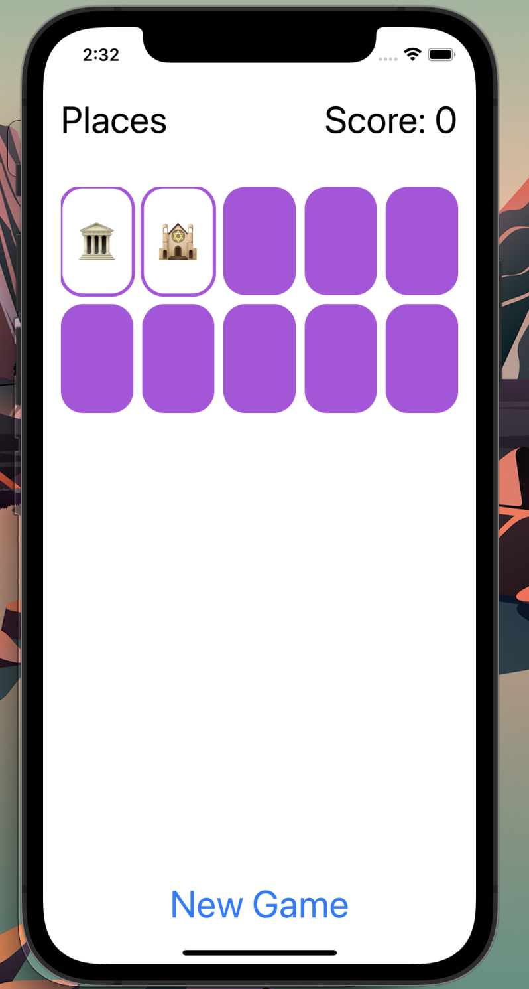

Step 2: Click on the third card, as expected first two cards are facedown, and the only chosen card is faceup.

Test case 2:

|  |  |
| --- | --- |
| Test Case | Check if two matching cards found scores should be updated by 2 |
| Expected Result | If two matching cards are found then score should get updated by 2 |
| Actual Result | As Expected. |

Step 1:

Select the two matching cards. Score updated to i

Also, the two matching cards vanish once the third card is chosen.

Test case 3:

|  |  |
| --- | --- |
| Test Case | Check if previously seen card is open again then score should get decreased by 1 |
| Expected Result | If previously seen card is open again then score gets decreased by 1 |
| Actual Result | As Expected. |

1. The following chosen card is marked as previously seen and if selected again then total score will decreased by 1

1. Score decreased by 1

Test case 4:

|  |  |
| --- | --- |
| Test Case | Check if new Theme gets launched if clicked on New Game button |
| Expected Result | New Theme is launched when clicked on New Game |
| Actual Result | As Expected. |

Initially cards with “Food” Theme launched.

When clicked on New Game theme is updated, and a new game is launched.

